Author Guidelines for the Advances in Architectural Geometry Conference, Vienna 2010
Alexander Schiftner
Evolute and TU Wien
Johannes Wallner
TU Graz
These author guidelines take care of two things: (i) Reviewers should be able to process all submissions in more or less the same way, and they should get an impression on how a paper will look in print. (ii) The accepted papers must be typeset in the same style, and must not contain low quality graphics.
The submitters are kindly asked to take the detailed instructions into account when preparing their submission, and in particularly when preparing the camera-ready version of their accepted paper. The easiest way to do that is to take the “Microsoft Word” and “LATEX” versions of this document as a template for their own paper.
- Introduction
The Advances in Architectural Geometry conference welcomes both short and long papers, which are being reviewed by the scientiﬁc committee, possibly by additional external reviewers, under the direction of the scientiﬁc chairs who make the decision to accept a paper for the AAG10 conference volume. In addition the paper can be invited for a plenary presentation at one of the two conference days; the other accepted papers are invited to present themselves in form of a poster.
The proceedings volume is produced from a camera-ready PDF ﬁle provided by the authors, and it is imperative that all papers use the same typefaces, font sizes, style of headings, size of print area, and so on. Therefore we ask you to follow the steps outlined in this document carefully when submitting your ﬁnal manuscript. It is recommended to follow the guidelines even for the ﬁrst submission, because the reviewers surely want to know how your paper will look like. You may as well use the LATEX source code or the Microsoft Word version of this document as a template to produce your paper.
Submission for reviewing must be done in in PDF format. The organizers are conﬁdent that each author has access to software capable of producing PDF ﬁles (very often you can simply print your document to create a PDF ﬁle). If you honestly believe that you don’t, please contact a knowledgeable colleague ﬁrst, and if this fails, contact the organizers.
- Instructions
The language of both conference and proceedings is English. The following instructions have been implemented in this template using styles, please reuse them for your own paper.
  - Margins and page numbering
Printed material, including text, illustrations, and charts, but excluding the page heading, must be kept within a print area 11.7 cm (4.6 inches) wide by 18.9 cm (7.44 inches) high. The top margin, i.e., the distance between top of the page heading and top of main text, is 12 mm. You can use page numbers for reviewing, but you must not have page numbers for the ﬁnal version.
  - Typefaces and Fonts
Wherever Times is speciﬁed, Times Roman may also be used. If neither is available on your word processor, please use the font closest in appearance to Times that you have access to (Make sure you use Type-1 fonts or True-Type fonts).
The title should be in Times 14-point, boldface type, and left-justiﬁed. Capitalize the ﬁrst letter of nouns, pronouns, verbs, adjectives, and adverbs; do not capitalize articles, coordinate conjunctions, or prepositions (unless the title begins with such a word). Leave two blank lines after the title.
The Author names and afﬁliations come beneath the title and are printed in Times 10-point (authors in boldface, afﬁliations non-boldface). Please leave two blank lines between title and authors, a half blank line between author and afﬁliation, and a blank line between afﬁliation and the next author.
The abstract should be fully-justiﬁed italicized text, below the author and afﬁliation information. Use the word “Abstract” as the title, in 10-point Times, boldface type, left-aligned to the text, initially capitalized. The main text is in 10-point Times, single-spaced. Do not use double-spacing.
All paragraphs should be indented 5 mm. Make sure your text is fully justiﬁed – that is, ﬂush left and ﬂush right. Please do not place any additional blank lines between paragraphs. Figure and table captions should be 9-point Times type. Page headings, starting with the second page, consist of the author names on odd pages, and the title on even pages. They are typeset in 9-point Times. Avoid footnotes if possible.
  - Section headings
First and second order headings can be numbered in the style seen here. Please do not number third order headings.
First order headings. They are in 12pt Times, bold-face type. They should be initially capitalized, ﬂush left, with one blank line before, and one blank line after.
Second order headings. They should be 10pt Times, otherwise same as the first order headings.
Third order headings. If you really need them, they should be typeset in italics, with one blank line before. They are followed by a period and the text.
  - Mathematical symbols
The usual guidelines apply: Symbols which designate a single entity (like A for the area, n for a number, etc.) should be typeset in italics, especially if they appear in the running text. Centered formulas may be used for emphasis.
The standard functions (like sin, cos, etc.) are not italicized.
If you are using Microsoft Word the easiest way to achieve acceptable formulas according to the above specification is to use the following web service: http://www.codecogs.com/components/equationeditor/equationeditor.php
Using this service generate a png-image with resolution 300 dpi of your formula, download and drag&drop it to Microsoft Word, scale it to 25%. Use the style „Formula“ for the paragraph containing the image of the formula in order to achieve correct line spacing. Another possibility is to use the builtin formula editor of Microsoft Word.
  - References
List all bibliographical references at the end of the paper, in alphabetical order, with author’s names in small capitals and book titles, journal names in italics (see the sample bibliography at the end of this text). Referencing is done by author(s) and year enclosed in square brackets: [Dandelin 1822], [Chu and Séquin 2002], [Pauly et al. 2008].
  - Illustrations, graphs and photographs
The proceedings will be printed in color. Usually graphics should be centered. If your paper includes images, it is very important that they are of sufﬁcient resolution to be faithfully reproduced. To determine the optimum size (width and height) of an image, measure the image’s size as it appears in your document (in millimeters), and then multiply those two values by 12. The resulting values are the optimum x and y resolution, in pixels, of the image. Image quality will suffer if these guidelines are not followed.
Example 1: An image measures 50 mm by 75 mm when placed in a document. This image should have a resolution of no less than 600 pixels by 900 pixels in order to be reproduced faithfully.
Example 2: Capturing a screenshot of your entire 1024 × 768 pixel display monitor may be useful in illustrating a concept from your research. In order to be reproduced faithfully, that 1024 × 768 image should be no larger than 85 mm by 64 mm (approximately) when placed in your document.
Make sure that the graphics you include in the paper have not been compressed or downsampled (as is usually the case with JPEG). Most image processing software has a way of specifying the exact amount of compression when saving an image, but the default value usually is too much. If your graphics has sharp edges, you must not use compression below 90%. Otherwise, the compression will be visible in print, such as illustrated by Figure 4b.
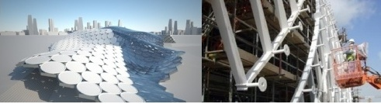
Figure 1: Sample figure with short centered caption.
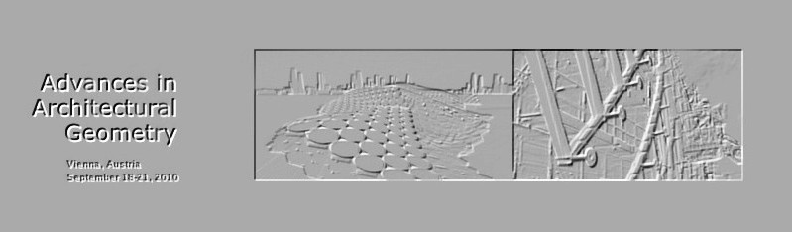
Figure 2: Sample ﬁgure with a longer caption which then is typeset in fully justiﬁed mode (both left and right). Figure captions should be typeset in 9 point Times. Contrary to the instructions found in this text, the present ﬁgure does not have sufﬁcient resolution to be printed this big.
(a)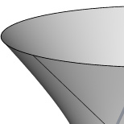 (b)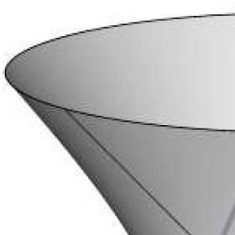
Figure 3: Magnified screenshots of PDF files. Left: Correctly assembled PDF file. Only minimal artifacts are visible in areas of high contrast. Right: Incorrectly assembled PDF file. Image compression has not been switched off, artifacts are clearly visible. The image is not fit for printing.
  - Hyphenation and typesetting of URLs
Some word processors do hyphenation automatically and some don't. The text becomes prettier if you use hyphens to break long words, because it keeps whitespace between words smaller. For your final accepted paper please introduce hyphens manually if necessary. Using Microsoft Word’s manual or automatic hyphenation is possible. A notorious problem in this context are URLs (references to the world wide web) which are often treated as a single word.
All URLs should be typeset in italics, like http://www.architectural geometry.at/aag10.
- Making PDF Files
When accepted, the final paper must be delivered as a PDF document which is not change protected, with all typefaces embedded, and graphics not downsampled /compressed. Different ways to achieve this are in more detail described below.
  - Checking if a PDF file is acceptable
In order to check if the final PDF file intended for publication is acceptable, please view it in Acrobat Reader, and have a look at the List of Fonts used in the document (see security settings / document properties). Each font must be embedded, and must be a Type-1 font or a True-Type font.
Zoom in on the graphics and check if they exhibit JPEG artifacts. Artifacts either are already contained in your original images or have been introduced by not producing the PDF file properly.
  - FreePDF
This tool is freely available and known to produce acceptable pdfs. It creates a new printer device called „FreePDF“ which you can print to from Microsoft Word or any other word processor. In order to install and use it please follow this procedure:

- Download the file gs864w32.exe from http://sourceforge.net/projects/ghost script/files/, you can find this file in the folder GPL Ghostscript / 8.64 on the website. Double-click it and install ghostscript into the default location.
- Download and install FreePDF 4.02 from http://freepdfxp.de/xpDown load.html. When installing, FreePDF will find ghostscript in its default location.
- Print to the printer FreePDF. After printing the graphical user interface of FreePDF will pop up. Choose the PDF Profile „High Quality“ and click „Edit Configuration“. Go to Profiles, again choose the Profile „High Quality“ and click „Change“. Select „PDF Pictures“ and set all image downsampling options to false. Click „Save“, close the configuration dialogue, and save the pdf.
  - Using other word processors with Acrobat Distiller
We recommend to download and install the version of the „CMW“ Adobe Acrobat Distiller job options file appropriate for your operating system and version of Acrobat from http://www.cadmusmediaworks.com/index2.html in the “(Operating System)/Applications/Distiller Settings” folder. The “CMW” job options ﬁle embeds all typefaces and does not downsample or subsample images when creating the PDF document.
- Upon acceptance
After acceptance of your paper, the publisher requires you to sign a form to the effect that the usual rights are transferred to him, and that you have all necessary rights to include your pictures in the paper. Further you will be notiﬁed if the chairs have selected your paper for plenary presentation.
Acknowledgements
We have borrowed shamelessly from the author instructions of Computer graphics conferences and journals, in particular from Eurographics and ACM SIGGRAPH.
References
CHU, C. H., AND SÉQUIN, C. 2002. Developable Bézier patches: properties and design. Comput. Aided Design 34, 511–528.
DANDELIN, G. P. 1822. Mémoire sur quelques propriétés remarquables de la focale parabolique. Nouv. Mèm. Ac. Sc. de Belgique 2, 172.
PAULY, M., MITRA, N. J., WALLNER, J., POTTMANN, H., AND GUIBAS, L. 2008. Discovering structural regularity in 3D geometry. ACM Trans. Graphics 27, 3, #43, 1–11. Proc. SIGGRAPH.
POTTMANN, H., ASPERL, A., HOFER, M., AND KILIAN, A. 2007. Architectural Geometry. Bentley Institute Press.
SCHIFTNER, A., RAYNAUD, J., BALDASSINI, N., BO, P., AND POTTMANN, H. 2008. Architectural freeform structures from single curved panels. In Advances in Architectural Geometry. TU Wien, Vienna, 45–48.

Authors’ address:

Alexander Schiftner (schiftner@evolute.at)
Technische Universität Wien
Wiedner Hauptstr. 8–10/104 — A 1040 Wien, Austria.

Johannes Wallner (j.wallner@tugraz.at)
Technische Universität Graz
Kopernikusgasse 24 — A 8010 Graz, Austria.

they should be typeset in 8-point Times.

